EXPERIMENT-29
NETWORK LAYER PROTOCOL HEADER ANALYSIS USING WIRE SHARK – ARP

AIM: To analyze capturing of Transport layer protocol header analysis using Wire shark- ARP
SOFTWARE USED:
Wire shark network analyzer
PROCEDURE:
- Open wire shark.
- Click on list the available capture interface.
- Choose the LAN interface.
- Click on start button.
- Active packets will be displayed.
- Capture the packets & select any IP address from the source.
- Click on the expression and select IPV4 →IP addr source address in the field name.
- Select the double equals (==) from the selection and enter the selected IP source address.
- Click on apply button.
- All the packets will be filtered using source address.
OUTPUT
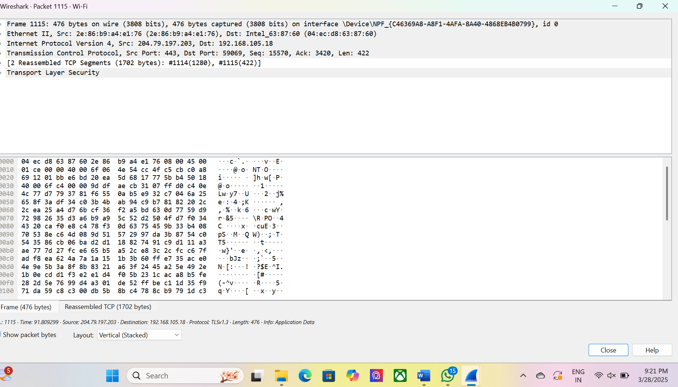

Result: Hence, the capturing of packets using wire shark network analyzer was analyzed for ARP

